New Eddies in the Current

The Newsletter of the Delphos Canal Commission

Volume 20 August 2010

5nd Annual German-Style Dinner

-- Brats – Kraut – Hot German Potato Salad –
-- Green Beans – Roll –Dessert --

Sunday, October 3, 2010

$7.00 – Presale Only – Time: 11 am to 1 pm
Carryouts only…Pick-up behind Museum in parking lot

Get your tickets from any trustee

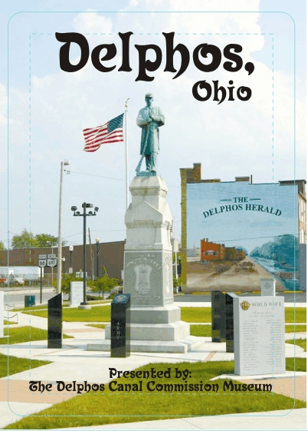

Deck of Cards

Our second deck of historical playing cards is at the printers and hopefully will be available during Canal Days. We are completely sold out of the first deck so if you want the second deck, do not wait too long. There are some really interesting pictures on the cards.

Meet the New Trustee

Gary Backus was born October 7, 1941 in Delphos to Clayton and Margaret (Linger) Backus, spending most of his early childhood in a Second Street apartment above Bud’s Barber Shop in the Metzger building. Then his family moved above the Delphos House on Main and Fourth Street. He started school at Franklin and his first grade teacher was Henrietta Eysenbach. The family then moved to South Main Street where he attended Lincoln School with Miss Werner as his teacher. In 1952 the family bought their first home on Moening Street.

Growing up in Delphos in the 40’s and 50’s was very enjoyable to Gary, especially during Tri-County Fair time. Other fond memories include when he and John Clark sang in the PTA Carnival talent show as 7th or 8th graders and when he and Bill Roth went to Oakwood Skating Rink to meet girls. He spent his summers mowing lawns for all his grade school teachers and he worked most summers at Tent & Awning, the Elevator, and St. Mary’s Foods.

Gary has 3 children from a former marriage and is now married to Nettie (Gunter) which gained him 7 step-children. He and Nettie are members of the Wesleyan Church where Gary has served on the board. His other hobbies are fishing, genealogy, and reading the Bible.

A love of history and a history of hard work are what Gary brings to the Canal Commission. He has been a faithful volunteer for the past 4 or 5 years, showing up most Thursday mornings to do whatever needs to be done from shoveling snow to repairing ceiling tile to “you-name-it”. He has seen many changes in Delphos and hates to see historical things torn down. He is a welcome addition to our board.

Renovation Update
Work on the second set of stairs is well underway. The block has been laid and the framing is finished. The drywallers have been scheduled and will start soon. Work on the second floor is also in progress. Part of the floor has been stained and when it is finished and dry, some displays can be set up.

We have had two planning meetings to decide how to display items and collections when the second floor is completed. We all agree the canal display should be on the first floor as our main focus. The remnants of the Marguerite have been moved from Tim Metzger’s barn to a semi-trailer and will be one of the first things put into the new space designated for the Canal Era display.

What’s Old That’s New at the Museum by Betty McKowen, Archivist
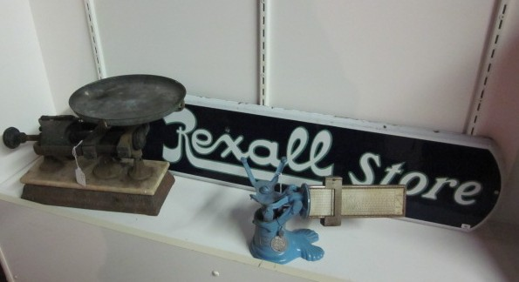
Helen Remlinger, widow of Remlinger Drugs owner and pharmacist Bill Remlinger, gave to the museum many, many articles from the Main Street store. This store was formerly owned by Bill’s father, Walter, and his uncle, Harold, both pharmacists. Among the articles is a large, very, very old scale. Also a blue scale with a note “tested and sealed, Ohio, Allen County.” There is a note pad with notes taken by Bill’s grandfather dated October 1, 1886 – March 12, 1887, and a small bottle with the notation “Pioneer Drug Store, Dr. C.C. Bliss, Prop., Delphos, O.” There are numerous apothecaries and many, many glass beakers ranging from 4 inches to 9 inches. The articles are too numerous to mention.

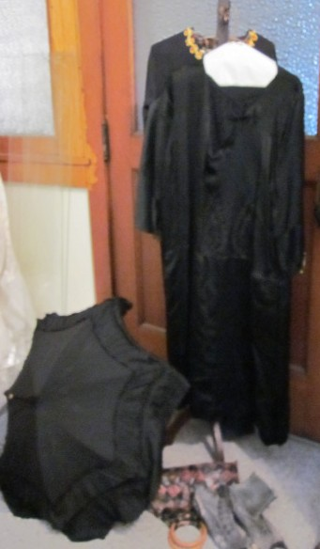
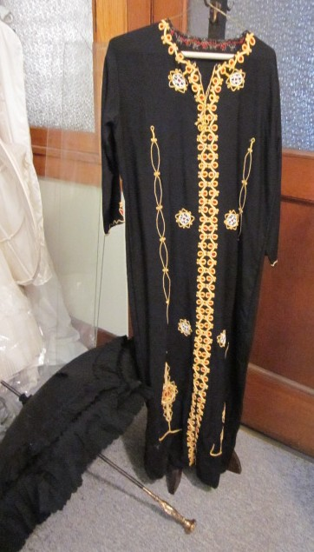
Cheryl Miller, at the request of her mother, Rita Grubenhoff, turned over to our museum a number of lovely items. There are several long black dresses and skirts, several blouses, an evening shawl, and an evening bag. There is also a fancy black umbrella with a gold handle engraved “Rose McKindly”. In addition to clothes, we received articles from the Pioneer Drug Store.

None of these items are on display at this time but will be seen as soon as our second floor extension of the museum is completed but do come in to see the “Song Book of Lucy Kently, August 31, 1897” and a red velvet autograph book with cook book recipes.

Financial Figures

To give you an idea of our financial status, here are some figures from January through December 2009 given at our Annual Meeting in April. Our total income for the year was $56,397. $31,500 of that was from grants and donations. Rent accounted for $14,000; fund raisers, $4,500; and membership dues, $1,700.
That may seem like a fair amount until one realizes our expenses were $60,551.
All grant monies are earmarked for specific building projects which must be specified when we apply for the grant, and may not be used for general operating expenses. Thus our total operating budget was about $25,000 of which $22,000 went for utilities, taxes, and insurance.

As noted above, last year’s fund raisers added $4500 to our income. The Boatmen’s Breakaway, the Booker open house and the German dinner were the largest money makers; while the Lincoln Highway garage sale, sale of the last of the historical playing cards, and concessions at the concert in the park added to the total. In addition, there were several smaller fund raisers.

Technology

You no doubt noticed this newsletter is in color. With digital cameras making it so easy to add pictures, we realized black and white did not do our pictures justice. Several of our trustees purchased and donated a new laser printer which makes printing in color affordable. Drew Kimmett volunteered to be our tech guy and installed it plus added memory to our old donated computer.

Many organizations are now sending their newsletters via email which really saves on postage, paper and ink. If you have an email address and would consider receiving our newsletter electronically to help us save money, send an email message to:
LBaker@woh.rr.com.

Twelfth Annual Christmas Tree Festival

Saturday November 27 thru Sunday December 19, 2010

Open Saturdays and Sundays from 1 to 4

Can you identify the business and location of each picture?

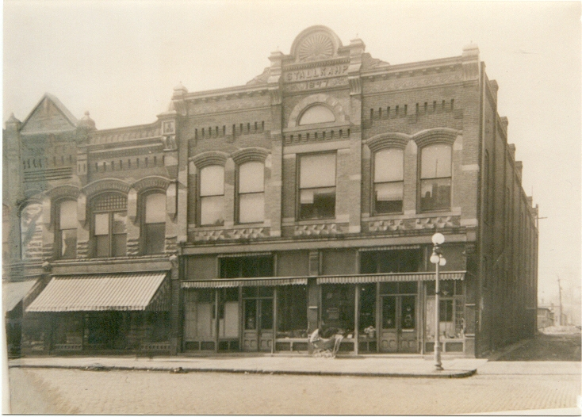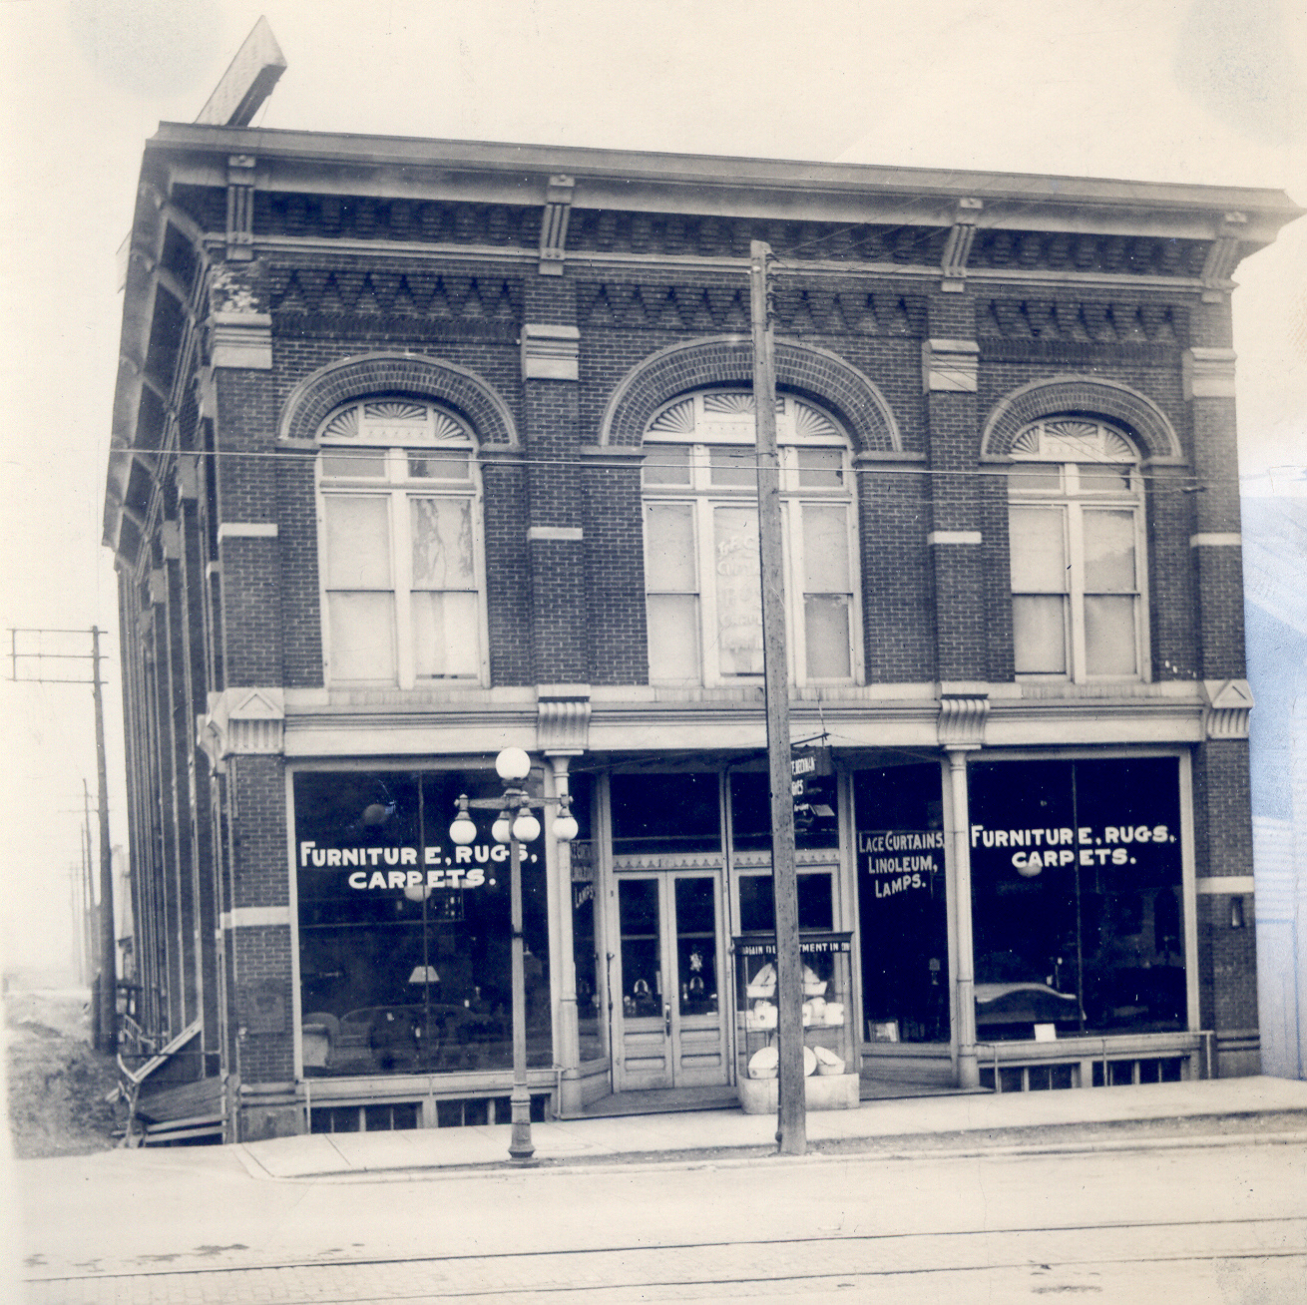

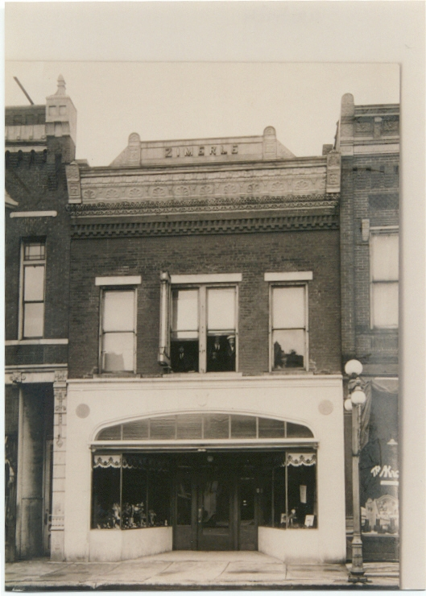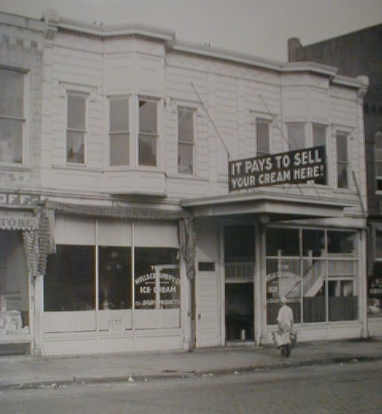

Give up? Call or visit the museum for answers.

