The Newsletter of the Delphos Canal Commission

Volume 25 July 2015

Meet The New Trustees…
Dave Desenberg
An Elida HS and BGSU graduate, Dave is married to Delphos native Cathy Clark and the couple, who have three children, have lived in Delphos since 1987. After teaching social studies at Elida High School for 30 years, Dave retired in 2013. That same fall he filled in as a social studies teacher at St. John’s HS and continues to teach there. In 2014 Dave began teaching a class on local history that he developed called History: In Your Backyard. The course covers the long and rich history of Delphos and its environs from its founding to the present day. Dave is excited for the opportunity to capture the legacy of those who have gone before us and share that legacy with our town’s young people.
Terrie Noonan
Terrie is spending the summer with her husband Ken Noonan at their cottage. We’ll hear her story in the next newsletter. In the meantime… Welcome, Terrie!!!

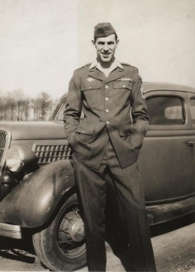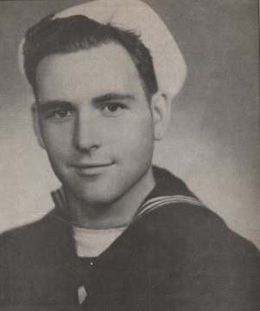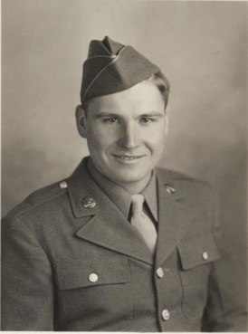
Art Grothouse Burl Morris Harold Liebrecht
World War II Roundtable
On Sunday, July 12 from 1:00pm-3:00pm the Canal Commission hosted three local World War II veterans in our first Roundtable Discussion. For nearly two hours veterans Art Grothouse, Harold Liebrecht and Burl Morris shared their stories and memories of their time in the military in the 1940’s. The entire event was professionally filmed and will be available for viewing.

This will be the first in a series of Roundtable Discussions at the Museum. Each Roundtable will focus on a different topic and feature local citizens who will share their stories and life experiences. Future topics might include farming, Delphos business owners, housewives, military veterans, life on the homefront during WWII, etc… If you have an idea for a Roundtable discussion, please share it with us.
Basement Updates

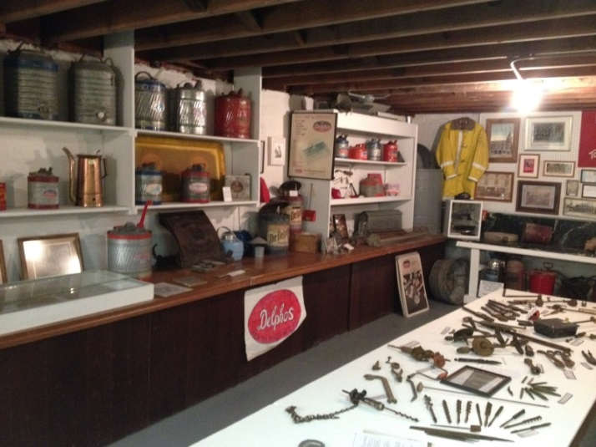

The final stage of remodeling at the Canal Museum, the basement, is nearing completion. Exhibits have been rearranged and organized and the basement floor and walls have been given a fresh coat of paint. New lighting is in the plans for the near future. Make sure to visit the newly refurbished basement during your next visit.

Tour Groups
This past spring nearly 200 tourists boarded tour buses and headed to Delphos to see the sights in our town. Museum of Postal History curator Gary Levitt organized the tours with an Ohio travel company. The visitors toured the Canal Museum and the Museum of Postal History before enjoying dinner at Baked To Perfection.

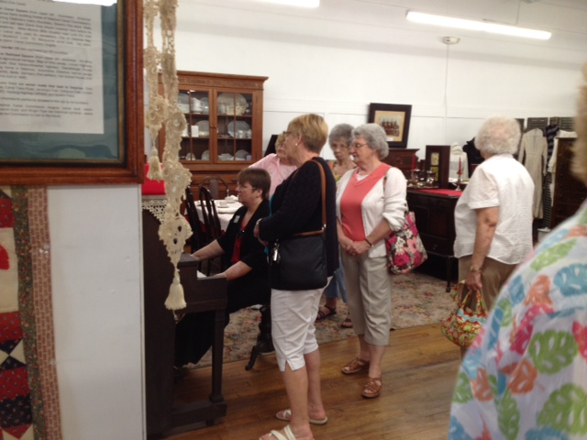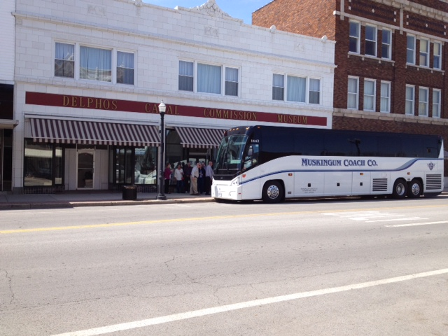
Visitors enjoy a turn on the A bus full of tourists debarks
Museum’s vintage player piano at the Canal Museum

Calendar of Events
September 12 Canal Clean Up for Canal Days
September 18-20 Canal Days!! Check the Delphos Herald for our special events!
October 4 German Dinner: Tickets $8, carry outs only. Pickup 11:00-1:00 at the Museum back door. Meal includes brats and kraut, German potato salad, applesauce, roll and cookie, all home cooked by descendants of authentic German immigrants!!
Boatman’s Breakaway Dinner
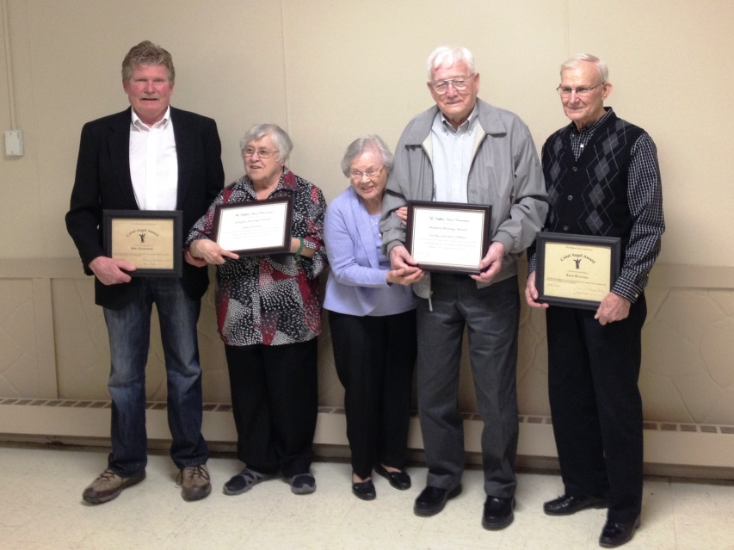
L-R: Mike Vanderhorst, Helen Kaverman, Dorothy and Elmer Hoffman and Louis Kaverman.
(Bob Holdgreve was absent)

The Canal Commission’s annual Boatman’s Breakaway dinner was held March 15 at the K of C Hall in Delphos. The evening featured a delicious, catered dinner, entertainment by “Banjo Phil, A Fiddler and Two Fat Fellas” and updates on activities at the Museum. The evening was capped off by the presentation of awards to special friends of the Canal Commission.

The Canal Angel Award, which recognizes those who have stepped up and helped with special projects at the museum or with the canal, was presented to Louis Kaverman and Mike Vanderhorst. The Delphos Heritage Award — a new award given to recognize people who have promoted the history of Delphos and the Canal Commission Museum — was awarded to Dorothy and Elmer Hoffman, Bob Holdgreve and Helen Kaverman.

From the President… 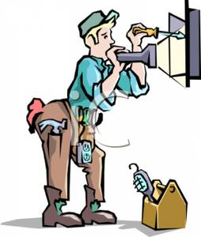

Donations are welcome to help with our electric wiring upgrade for the basement and for materials to build new displays. If you’d like to help, The 100 Best Friends plaque is a great way to show your support for the Museum by donating $1,000 or more to a worthy cause. Smaller donations are quite welcome, too. All donations are tax deductible, tax I.D. is 34-1667265.
Delphos Canal Commission
241 N Main St
Delphos OH 45833

Officers
President Lou Hohman
Vice President Steve Dorsten
Secretary Teresa Bradstock
Treasurer Marilyn Wagner

Board of Trustees
Kay Ahten Jim Marihugh
Gary Backus Mike Miller
Linda Baker Tom Miller
Dave Desenberg Terrie Noonan
Bob Ebbeskotte Kelly North
Dorothy Hoffman Barb Seffernick
Elmer Hoffman Ed Ulrich
Pete Hofmann

Phone #: 419-695-7737
Email: info@delphoscanalcommission.com
Website: www.delphoscanalcommission.com
Facebook page: Delphos Canal Commission

Delphos Canal Commission Shirts Available

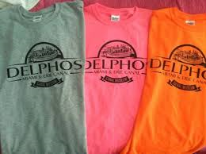

Shirts are available at the Museum! Children and adult sizes in a variety of colors. They start at only $10!
Visit our Museum store for other neat, history-related gifts including playing cards, books, hats, etc… Proceeds from your purchases support your Museum.

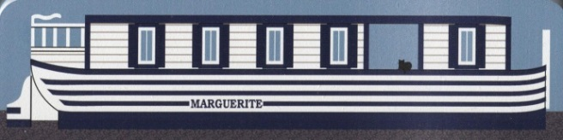
Marguerite Wooden Figurines $15

2016 Canal Museum Calendars will arrive in July. Check out 12 exciting, NEW photos!!!

